**Parking Portal**

1. **PURPOSE:**Setting up a new standard way to collect parking (VEHICLE) documents efficiently and enforcing them effectively through digitalization. Reduces operational time i.e. (It saves the time for managers in the process of collecting documents from every unit, verify them, scan them and again email them to the authorized person).
2. **SCOPE:**
3. To streamline the entire manual processes of documentation into digitalization.
4. To make data-driven decisions with real-time data.
5. To save the time of manager.
6. To create direct contact with tenants for the documentation process.
7. **DEFINATION:** To understand the need and importance of the documents, before allocation of the parking space and stickers to the tenants we need to verify whether the documents are expired or relevant, if documents are relevant, we will provide the stickers and parking space for the same. Tenant will receive the email notification 30 days prior of expiry date as per the documents received and they must provide the new relevant documents for the same.
8. **TECHNOLOGIES TO BE USED:**

**Frontend:** HTML, CSS, JSP.

**Backend:** Java 8.

**Farmwork:** Spring.

**Database:** MYSQL (Ver 8.0.20).

**Server:** Tomcat (Ver 8.5.84).

**IDE:** Spring Boot (Ver 4.17), MYSQL Workbench.

1. **IDENTIFICATION OF NEEDS:**

This project essentially needs functions:

1. It will be helpful for management to keep track of parking details.
2. Direct contact with tenants for the documentation process.
3. **USER CHARACTARISTICS:**

**i) ADMIN:** Can login/logout.

Can manage the parking system.

Can add/view/edit/update users database.

Can Accept/Reject Documents

Can allot parking space to tenants.

**ii) REGISTERED USER:** Can login/logout.

Can view/upload/update documents.

1. **SOFTWARE DEVELOPMENT PROCESS:** 
   * 1. **Prototype model:** Used for UI (User Interface) part of the project.

Simple data processing application.

Easily detect missing functionality.

* + 1. **Evolutionary model:** Used for object-oriented development.

Reduce the error/risk of software.

1. **USER CASE DIAGRAM**

**<Includes>**

**<Includes>**

**USER**

**<Includes>**

**<Includes>**

**ADMIN**

Checked Parking slot availability,

Allot parking space

1. **ACTIVITY DIAGRAM**

**No**

**yes**

Property Information

**Try again/forgot password**

Valid Username & password

Login

**USER**

**Admin**

Admin Login

**No**

Valid Username & password

View/upload/update documents

**yes**

View, Update, Delete, Edit, Accept/Reject Doc database

**10. ER DIAGRAM**

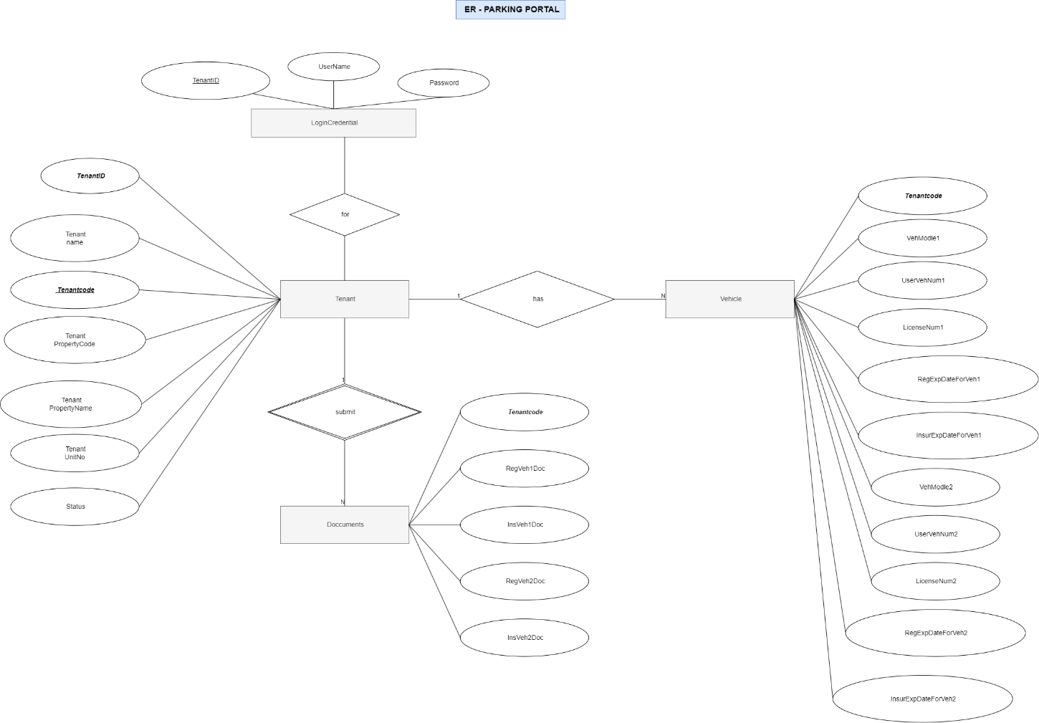

**Parking Portal**

# **User Login**

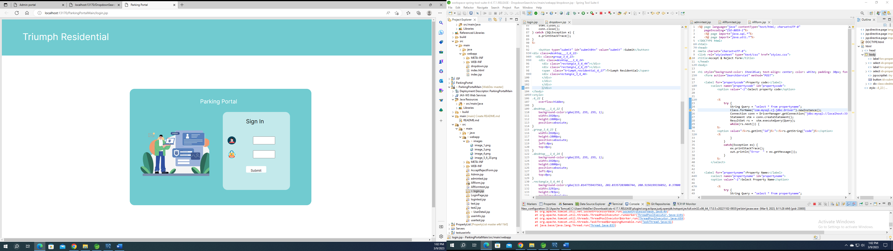

## **User Login Portal**

Username: t0031235

Password: Leighton@C

Database

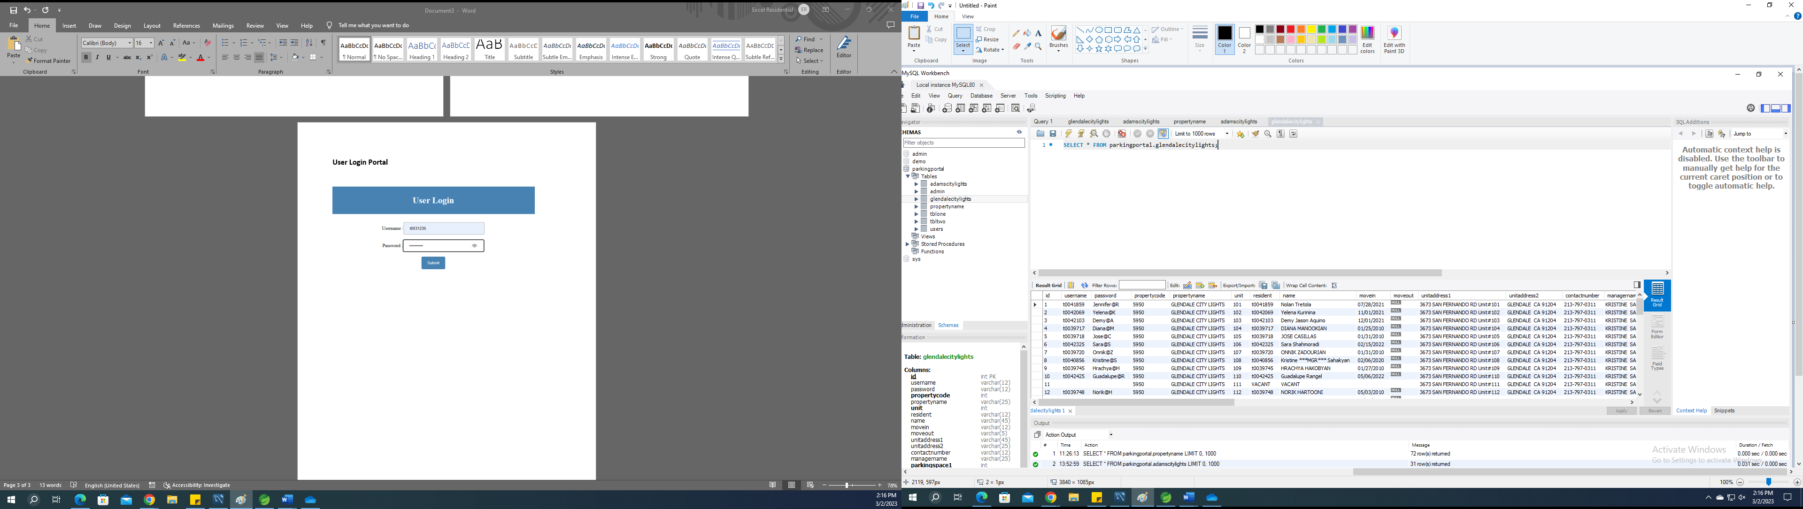

Put username and password in login Field and then click on submit button

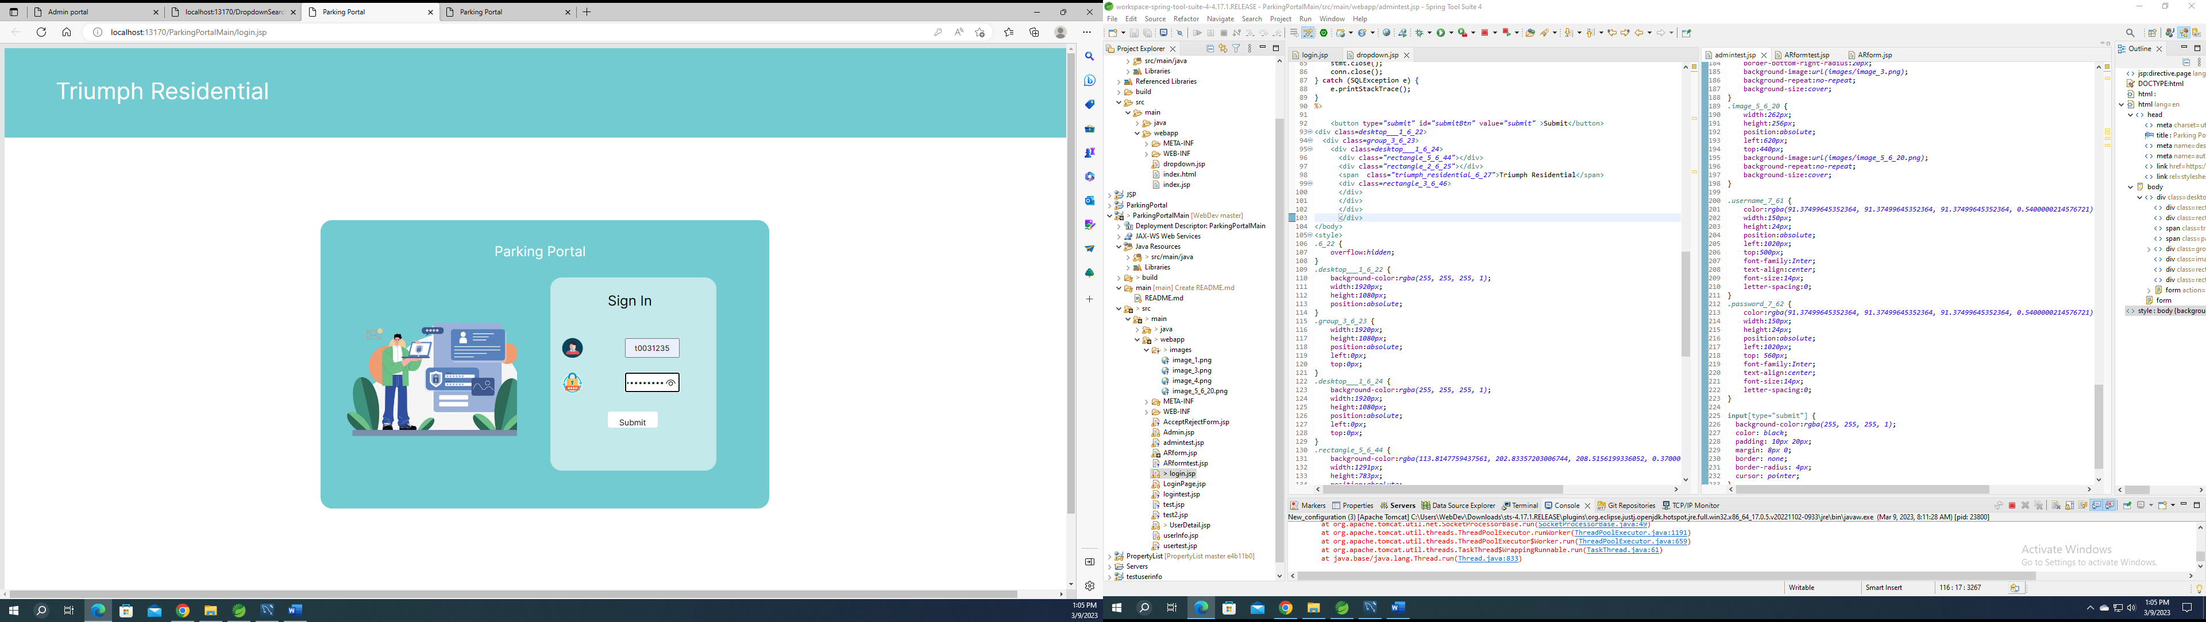

## **If username and password valid -> Open the User detail page**

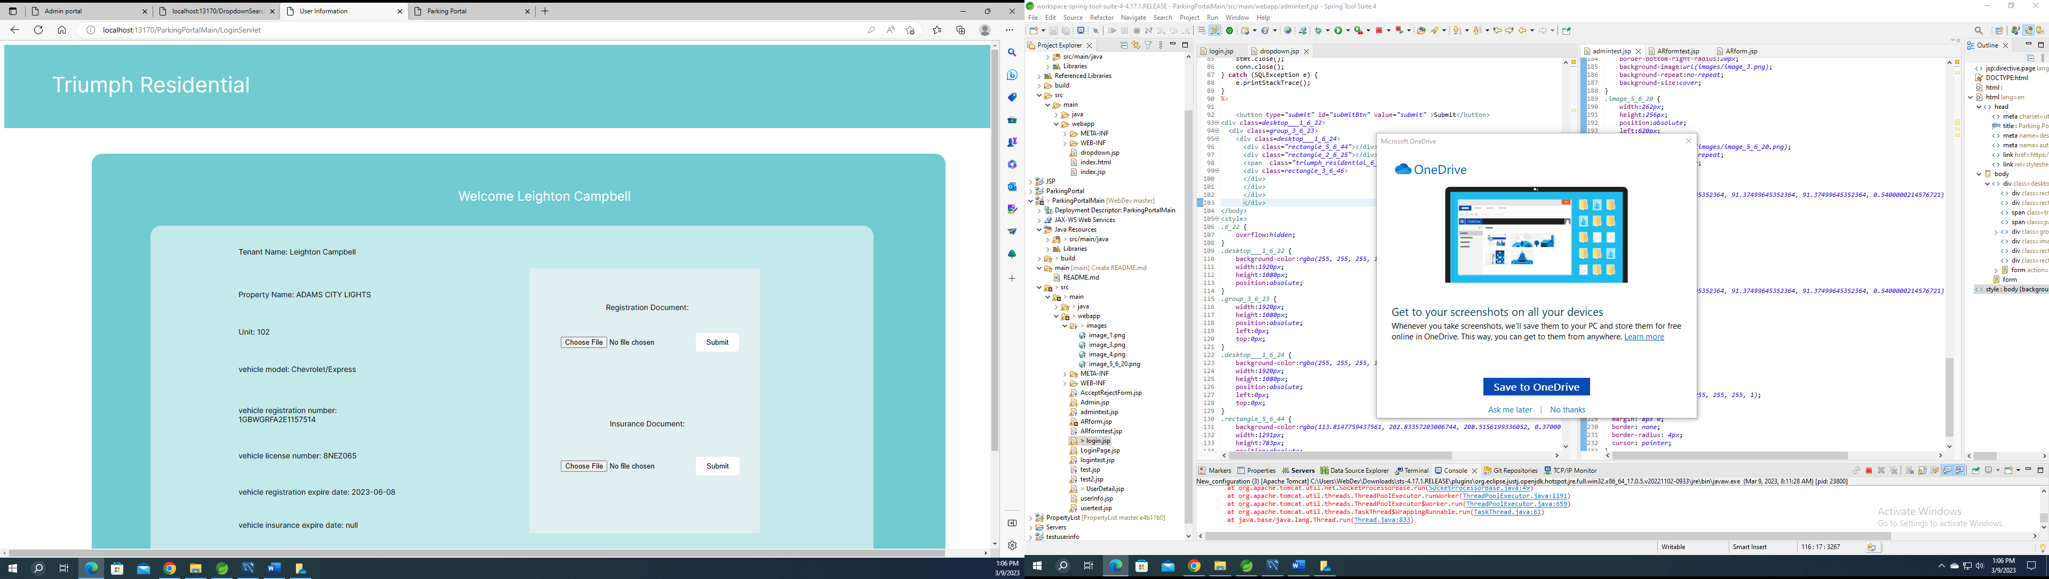

* User can upload and update their documents in portal

Steps for uploading Documents:

1. Click on Choose file

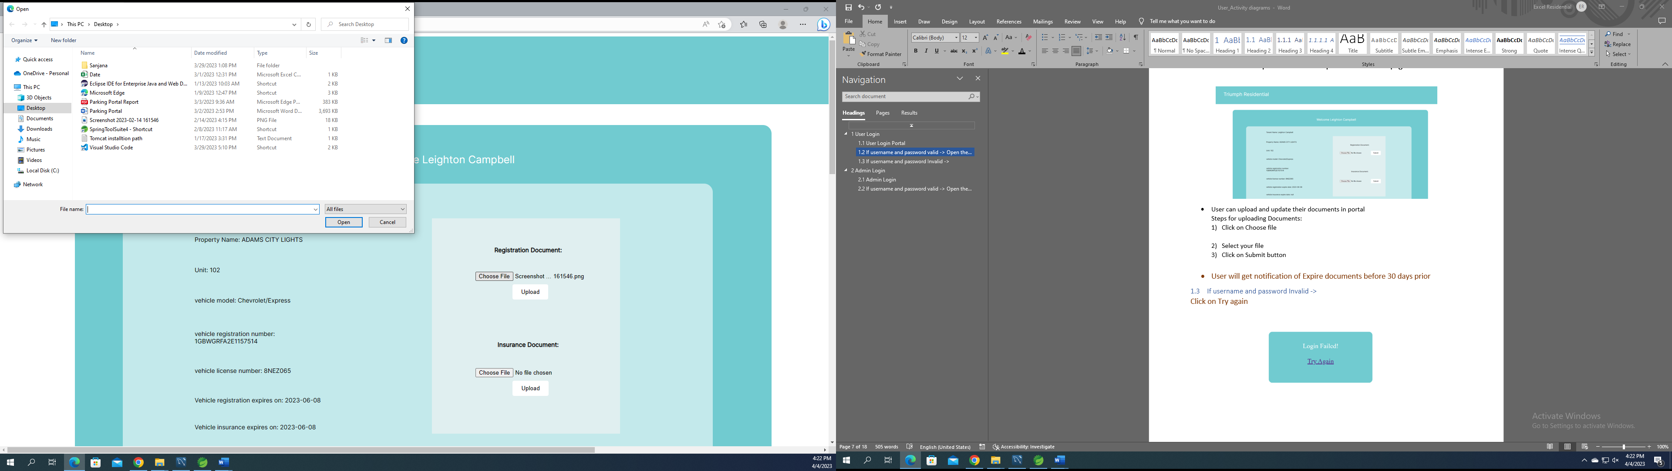

1. Select your file

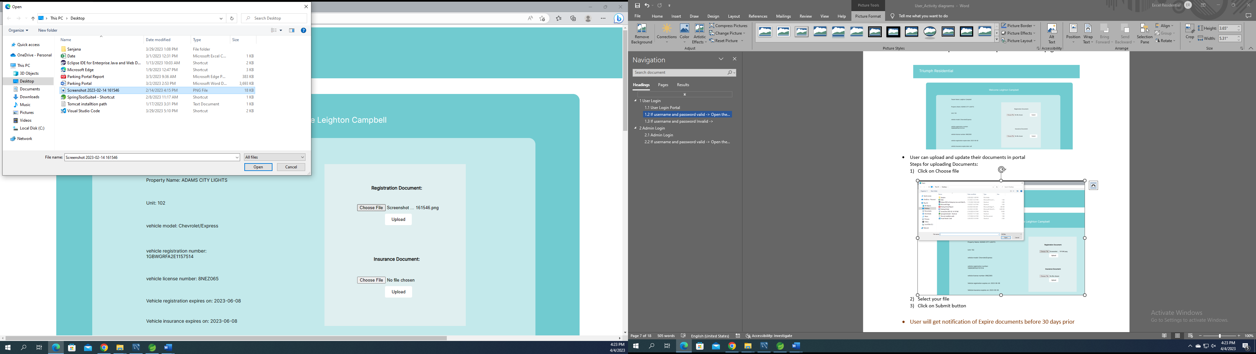

1. Click on Upload button

* User will get notification of Expire documents before 30 days prior

## **If username and password Invalid ->**

Click on Try again

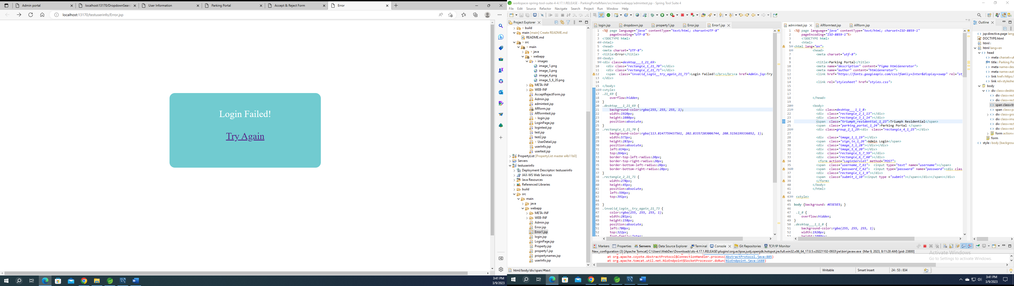

# **Admin Login**

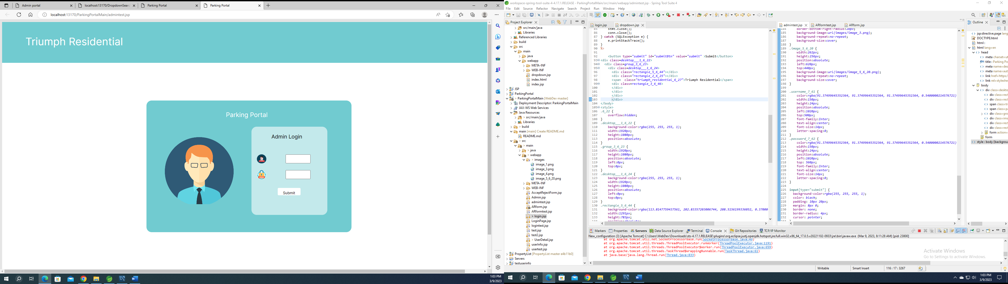

## **Admin Login**

Put username and password in login Field and then click on submit button

Username: admin

Password: admin

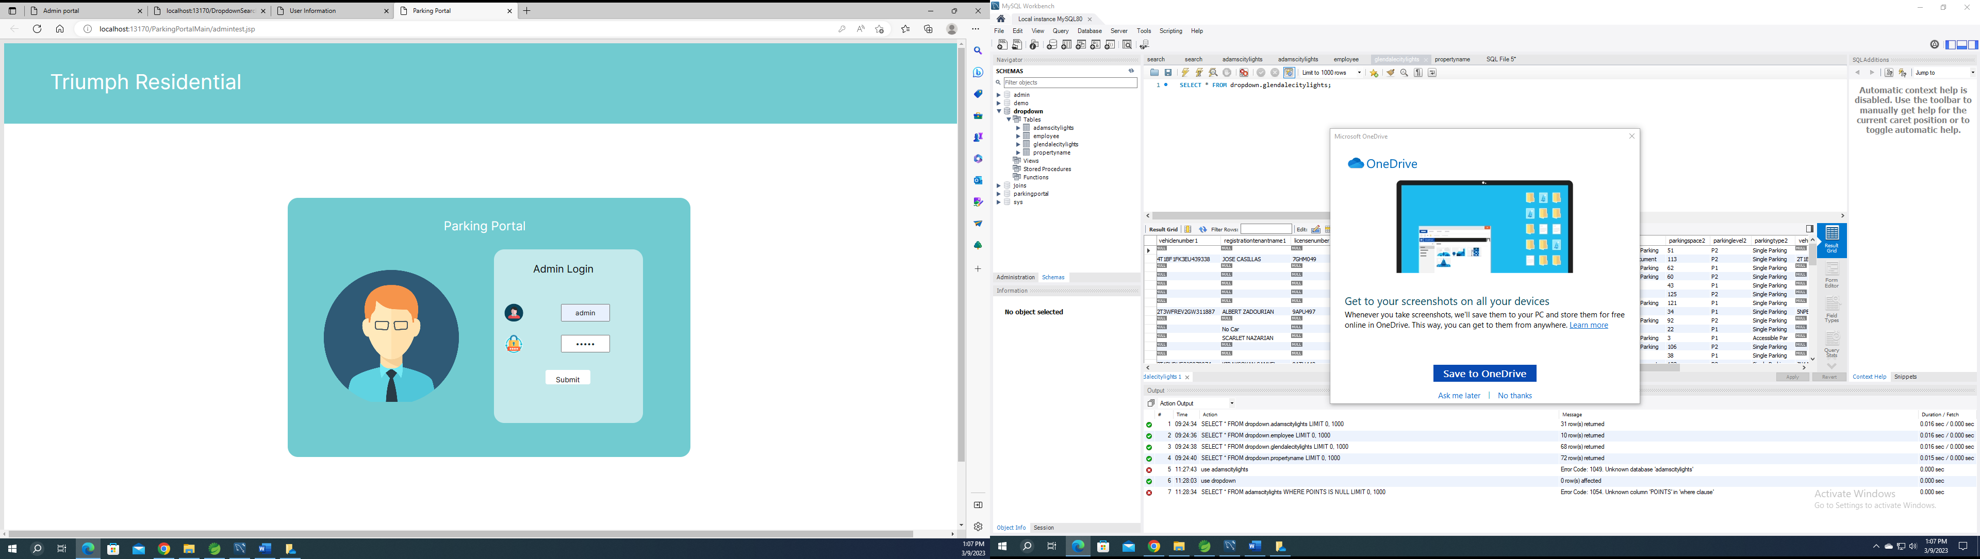

## **If username and password valid -> Open the Admin Portal**

It contains property name list dropdown

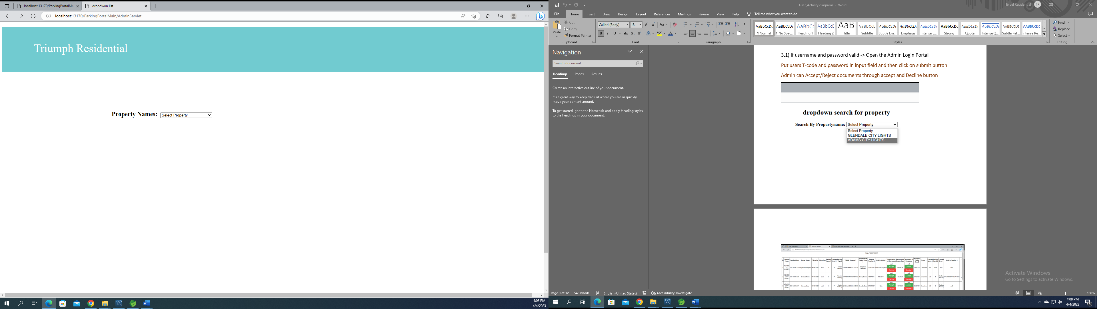

If you click on select property, first it will show all 72 properties name

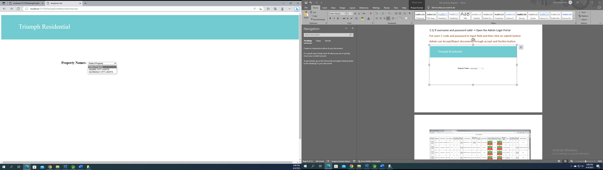

Click on any property name

For eg. Click on adams city light

